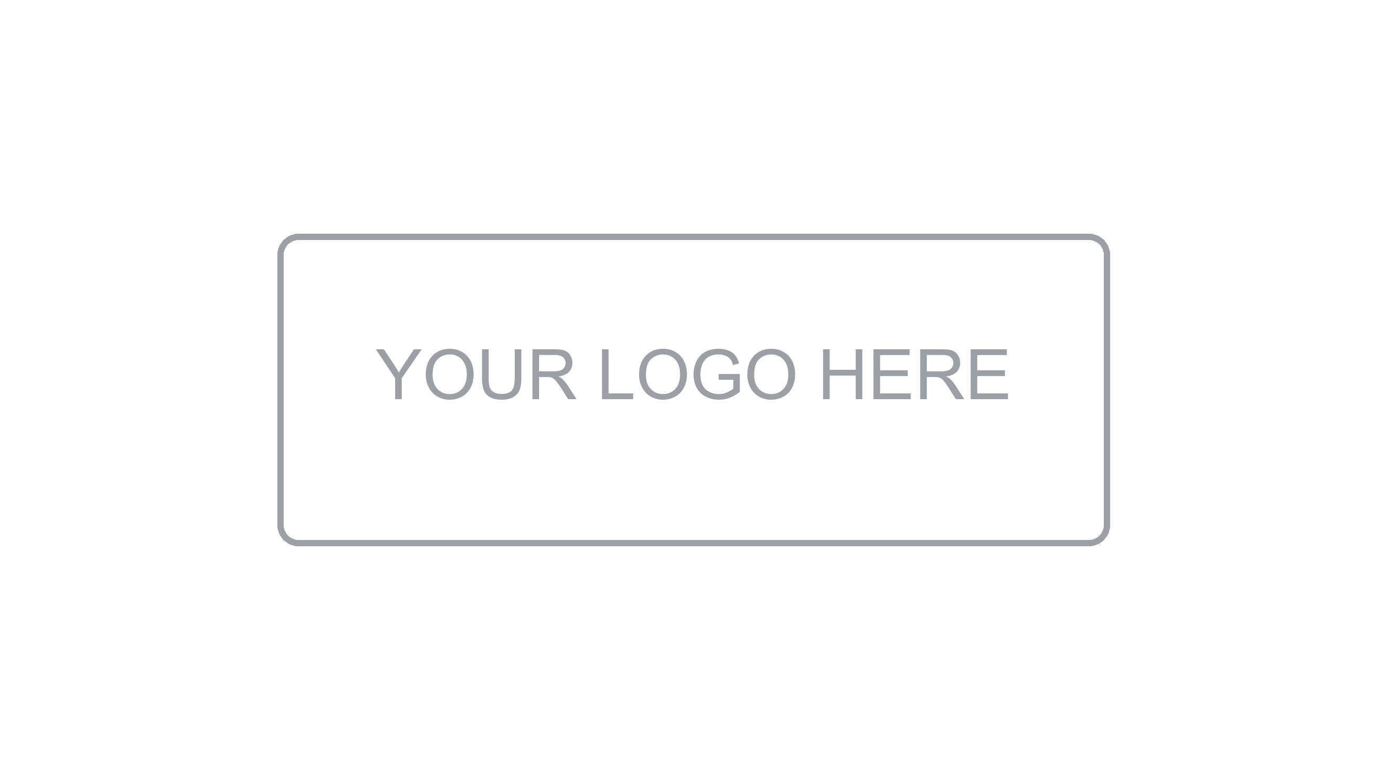

Onboarding /
Developer Guide

DETONATOR
Version [0,01] | [July 2026]
Prepared by: Ricardo Pineda | ITS

About this document
Onboarding / Developer Guide

What is this document?
This guide is the single source of truth for anyone joining the development team. It provides everything a new developer needs to be productive from day one: how to set up the local environment, understand the project structure, follow team conventions, and navigate the development workflow. It also serves as an ongoing reference for established team members.
Who should read it?
This document is intended for new developers joining the team, contractors and external collaborators, and any team member needing a reference for project conventions, tooling, or workflow.
What does it contain?
Document Information & Change History | Version control, authorship, and revision log of this document.
Introduction | Purpose, audience, and how to use this guide.
Team & Contacts | Team structure, key contacts, and communication channels.
Local Environment Setup | Step-by-step guide to get the development environment running in under 30 minutes.
Project Structure | Monorepo or repository layout, folder conventions, and where to find things.
Development Workflow | Branching strategy, commit conventions, PR process, and code review guidelines.
Coding Standards & Style Guide | Language-specific conventions, linting, formatting, and naming rules.
Testing Locally | How to run unit, integration, and E2E tests on the local machine.
Deployment & Environments | Overview of available environments and how deployments are triggered.
Troubleshooting & FAQs | Common issues, known gotchas, and where to get help.
References & Approvals | Related documents and formal sign-off section.

1. Document Information

Project | [Project Name]
Document Type | Onboarding / Developer Guide
Version | [X.X]
Author(s) | [Name(s)]
Reviewer(s) | [Name(s)]
Date | [DD/MM/YYYY]
Status | [Draft / In Review / Approved]

2. Change History

Version | Date | Author | Description of Change
1.0 | [DD/MM/YYYY] | [Name] | Initial version

3. Introduction

3.1 Purpose
[Describe the purpose of this guide. Example: This document provides the complete onboarding reference for developers joining the [Project Name] team, covering environment setup, conventions, workflow, and key contacts.]

3.2 How to Use This Guide
If you are new to the team, follow sections 4 through 8 in order — they are designed to get you from zero to a running development environment and your first pull request. After onboarding, use this document as an ongoing reference for conventions and workflow.

💡 Tip
Estimated time to complete initial setup: 30–60 minutes. If you get stuck at any step, check Section 10 (Troubleshooting) first, then reach out to your onboarding buddy.

4. Team & Contacts

4.1 Team Structure
Role | Name | Responsibility | Contact
Tech Lead | [Name] | Technical decisions, architecture, code review | [email / Slack]
Product Owner | [Name] | Requirements, priorities, feature acceptance | [email / Slack]
DevOps / Infra Lead | [Name] | Environments, CI/CD, infrastructure | [email / Slack]
QA Lead | [Name] | Test strategy, quality gates, defect management | [email / Slack]
Onboarding Buddy | [Name] | Your go-to person for questions during your first weeks | [email / Slack]
[Role] | [Name] | [Responsibility] | [Contact]

4.2 Communication Channels
Channel | Platform | Purpose | Notes
#[project]-dev | Slack | Day-to-day development discussion | Primary dev channel
#[project]-alerts | Slack | CI/CD and monitoring alerts | Automated only
#[project]-general | Slack | General project updates and announcements
Team standup | Zoom / Meet | Daily sync — [time] [timezone] | [Meeting link]
Sprint planning | Zoom / Meet | Bi-weekly — [day] at [time] | [Meeting link]
[Channel] | [Platform] | [Purpose] | [Notes]

5. Local Environment Setup
[Goal: get a fully working development environment running in under 30 minutes. Follow each step in order.]

5.1 Prerequisites
Install the following tools before starting. Links point to official installation guides:

Tool | Version | Installation | Verify
Git | 2.40+ | https://git-scm.com | git --version
Node.js / [Runtime] | [x.x]+ | https://nodejs.org (use nvm) | node --version
Docker | 24.x+ | https://docs.docker.com/get-docker | docker --version
[Package Manager] | [x.x]+ | [URL] | [command]
VS Code / [IDE] | Latest | [URL] | —
[Other tool] | [version] | [URL] | [command]

5.2 Step-by-Step Setup

Step 1 — Clone the Repository
git clone https://github.com/[org]/[repo].git
cd [repo]

Step 2 — Install Dependencies
npm install # or: yarn install / pnpm install

Step 3 — Configure Environment
cp .env.example .env
Open .env and fill in the required values. Ask your onboarding buddy for any secrets not in the template.

Step 4 — Start Services (Docker)
docker compose up -d # starts database, cache, and dependencies

Step 5 — Run Database Migrations
npm run migrate # applies pending migrations

Step 6 — Seed Development Data
npm run seed # populates local DB with sample data

Step 7 — Start the Application
npm run dev # starts the app with hot reload
The application should now be running at http://localhost:[PORT]

✅ Setup Complete
If all steps completed without errors, your environment is ready. Run npm test to confirm all tests pass on a clean install.

5.3 IDE Recommended Extensions
Extension | IDE | Purpose
ESLint | VS Code | Real-time linting feedback
Prettier | VS Code | Auto-formatting on save
GitLens | VS Code | Enhanced Git blame and history
Docker | VS Code | Container management from IDE
REST Client / Thunder | VS Code | API testing without leaving the IDE
[Extension] | [IDE] | [Purpose]

6. Project Structure
[Describe the repository layout. If this is a monorepo, describe the workspace structure. Explain where key directories live and what they contain.]

6.1 Repository Layout
[repo-root]/
├── apps/
│ ├── [frontend]/ # Frontend application
│ └── [backend]/ # Backend API / services
├── packages/
│ ├── [shared-types]/ # Shared TypeScript types
│ └── [shared-utils]/ # Shared utility functions
├── infra/ # Infrastructure as Code (Terraform / CDK)
├── docs/ # Project documentation
├── scripts/ # Utility scripts (migration, seeding, etc.)
├── .github/ # CI/CD workflows and PR templates
├── docker-compose.yml # Local dev services
└── [config files] # Root-level config (eslint, prettier, tsconfig)

6.2 Key Files
File / Folder | Description
.env.example | Environment variable template — copy to .env and fill in values
docker-compose.yml | Local service definitions (database, cache, queues)
CLAUDE.md / README.md | Project overview and quick-start reference
package.json | Root scripts and workspace definitions
.github/workflows/ | CI/CD pipeline definitions
infra/ | Infrastructure as Code — Terraform / CDK modules
[Other key file] | [Description]

7. Development Workflow

7.1 Branching Strategy
Branch | Purpose | Naming Convention | Notes
main | Production-ready code | — | Protected — no direct pushes
develop | Integration branch | — | Protected — merge via PR only
feature/* | New features | feature/[ticket-id]-[desc] | e.g. feature/PROJ-123-user-auth
fix/* | Bug fixes | fix/[ticket-id]-[desc] | e.g. fix/PROJ-456-login-error
hotfix/* | Urgent production fixes | hotfix/[desc] | Branches from main
chore/* | Maintenance, deps, refactoring | chore/[desc]

7.2 Commit Conventions
All commits must follow the Conventional Commits specification:

type(scope): short description

# Examples:
feat(auth): add OAuth2 login flow
fix(api): handle null response from payment service
chore(deps): update eslint to v9
docs(onboarding): add IDE extension recommendations

Type | When to Use
feat | A new feature or capability
fix | A bug fix
chore | Maintenance tasks — dependency updates, refactoring, config changes
docs | Documentation changes only
test | Adding or updating tests
ci | Changes to CI/CD pipeline configuration
refactor | Code restructuring with no functional change
perf | Performance improvements

7.3 Pull Request Process
- Create a branch from develop following the naming convention above
- Develop your changes locally — keep PRs focused and small (< 400 lines ideally)
- Ensure all tests pass and linting is clean before opening the PR
- Open a PR against develop using the PR template — fill in all sections
- Request review from at least [N] team members (required: Tech Lead or designated reviewer)
- Address all review comments — mark resolved when done
- PR is merged by the reviewer once approved and all checks pass
- Delete the feature branch after merge

⚠ Rule
Never force-push to main or develop. Never merge your own PR without approval. If a PR sits unreviewed for more than 2 business days, ping the reviewer directly.

7.4 Code Review Guidelines
As an author:
- Keep PRs small and focused — one concern per PR
- Write a clear PR description explaining what changed and why
- Self-review your diff before requesting review
- Respond to all comments — even if just acknowledging

As a reviewer:
- Review within 1 business day of being assigned
- Distinguish blocking issues from suggestions (use "nit:" prefix for minor style notes)
- Approve only when you would be comfortable owning the code
- Be constructive and specific — explain the why, not just the what

8. Coding Standards & Style Guide

8.1 General Principles
- Write code for the next developer, not just the compiler
- Prefer clarity over cleverness — readable code is maintainable code
- Follow the Boy Scout Rule: leave the code cleaner than you found it
- No commented-out code in commits — use git history instead
- Functions and methods should do one thing and do it well

8.2 Naming Conventions
Element | Convention | Example
Variables | camelCase | userProfile, isAuthenticated
Constants | SCREAMING_SNAKE_CASE | MAX_RETRIES, DEFAULT_TIMEOUT
Functions / Methods | camelCase, verb-first | getUserById(), validateInput()
Classes | PascalCase | UserService, OrderRepository
Files (JS/TS) | kebab-case | user-service.ts, auth-middleware.ts
Database tables | snake_case, plural | user_accounts, order_items
API endpoints | kebab-case, plural nouns | /user-accounts, /order-items/{id}
Environment vars | SCREAMING_SNAKE_CASE | DATABASE_URL, JWT_SECRET

8.3 Linting & Formatting
Linting and formatting are enforced automatically via pre-commit hooks:
npm run lint # run ESLint
npm run lint:fix # auto-fix fixable issues
npm run format # run Prettier

💡 Tip
Install the ESLint and Prettier VS Code extensions and enable "Format on Save" in your IDE settings. This prevents most linting failures before you even commit.

8.4 Documentation in Code
- All public functions, classes, and exported modules must have JSDoc / equivalent comments
- Inline comments should explain WHY, not WHAT — the code shows what, comments explain intent
- Complex algorithms or non-obvious decisions must include a comment with the reasoning
- TODO comments must include a ticket reference: // TODO [PROJ-123]: refactor after migration

9. Testing Locally

9.1 Running Tests
Command | What it Runs
npm test | All tests (unit + integration)
npm run test:unit | Unit tests only
npm run test:integration | Integration tests (requires services running via docker compose)
npm run test:e2e | End-to-end tests against local environment
npm run test:coverage | All tests with coverage report
npm run test:watch | Unit tests in watch mode — re-runs on file change

9.2 Coverage Requirements
[Describe the minimum code coverage thresholds enforced by the CI pipeline. Example: The CI pipeline enforces a minimum of 80% line coverage for all packages. PRs that reduce coverage below this threshold will fail the coverage gate.]

⚠ Note
Integration tests require Docker services to be running. Run docker compose up -d before executing integration or E2E tests locally.

10. Deployment & Environments

10.1 Available Environments
Environment | URL | Deployment Trigger | Purpose
Development | http://localhost:[PORT] | Local — manual | Local development and testing
Staging | https://staging.[domain].com | Merge to develop — automatic | QA validation and stakeholder demos
Production | https://[domain].com | Merge to main — manual approval | Live system

10.2 How Deployments Work
- Pushing to develop triggers the CI pipeline: build → test → lint → deploy to staging
- Deployment to production requires a PR from develop to main with Tech Lead approval
- All deployments are logged in the CI/CD platform with rollback capability
- Never deploy directly to staging or production — all changes go through the pipeline

[For detailed deployment instructions, refer to the Installation & Deployment Manual.]

11. Troubleshooting & FAQs

11.1 Common Setup Issues
Issue | Likely Cause | Solution
Port already in use | Another process is using the required port | Run: lsof -i :[PORT] to find the process, then kill it
Docker containers fail to start | Docker daemon not running or port conflict | Start Docker Desktop / daemon, check docker compose logs
Database connection refused | DB container not running or wrong credentials in .env | Run docker compose up -d db, verify DB_* vars in .env
npm install fails with ERESOLVE | Node version mismatch | Use nvm to switch to the correct Node version: nvm use
Environment variables not loading | .env file missing or not in the right directory | Confirm .env exists in project root (not .env.example)
Migration errors on startup | Pending or conflicting migrations | Run npm run migrate:status, then npm run migrate
[Issue] | [Cause] | [Solution]

11.2 Frequently Asked Questions
Question | Answer
How do I get access to the staging environment? | Request access from the DevOps Lead ([contact]). Access is granted via [IAM / VPN / SSO].
How do I request a new environment variable or secret? | Open a ticket in [Jira / Azure DevOps] with the variable name, description, and required environments. The DevOps Lead will provision it.
Can I merge my own PRs? | No. All PRs require at least one approval from a team member other than the author.
Where do I report a production incident? | Post in #[incident-channel] immediately. Follow the incident runbook in the Operation & Maintenance Manual.
How do I add a new package or dependency? | Discuss with the Tech Lead first if it is a significant dependency. For minor utilities, open a chore/* PR with justification in the description.
[Question] | [Answer]

11.3 Where to Get Help
- First: check this guide and the project README
- Second: search the team Slack channels and pinned messages
- Third: ask your onboarding buddy
- Fourth: post in #[project]-dev with context — what you tried, what happened, what you expected
- For infrastructure issues: contact the DevOps Lead directly

12. References and Related Documents
Document | Description | Location / Link
Architecture Documentation | System structure and technical decisions | [Link / Path]
API Documentation | Full API reference | [Link / Path]
Installation & Deployment Manual | Environment setup and CI/CD pipeline | [Link / Path]
Operation & Maintenance Manual | Monitoring, incidents, and runbooks | [Link / Path]
Requirements Documentation | Functional and non-functional requirements | [Link / Path]
README.md / CLAUDE.md | Quick-start and project overview | [Repo root]

13. Approval

Role | Name | Signature | Date
Author | [Name] |  | [DD/MM/YYYY]
Tech Lead | [Name] |  | [DD/MM/YYYY]
Project Manager | [Name] |  | [DD/MM/YYYY]

